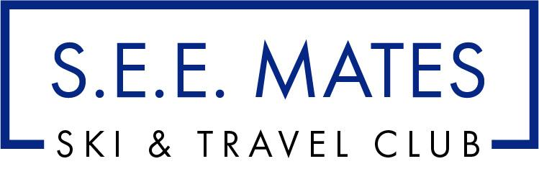
presents
BIG SKY, MONTANA
January 8 - 15, 2022 (Sat-Sat)

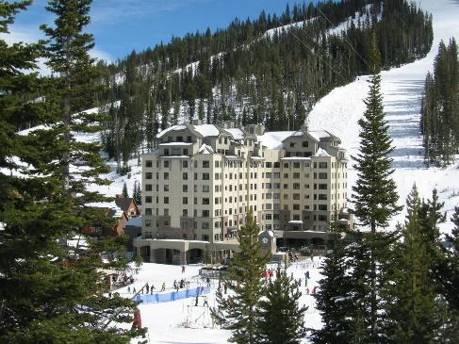
Ski – Explore – Experience Big Sky next season! Did you know that Big Sky offers one of the longest lift-served vertical drops in the USA and has won numerous awards for its uncrowded slopes and virtually non-existent lift lines.? Or, that there is an average of less than two skiers per acre on the busiest days? Big Sky's tram rises to the top of Lone Mountain and features 3,500 acres of steeps, chutes, long cruisers and bowls and it is all buried under more than 33 feet of annual snowfall. Now how’s that for snowfall?
We will stay at The Summit Hotel at Big Sky Resort offering ski-to-door access! The Big Sky, Montana resort is approximately an hour drive from Bozeman/Yellowstone International Airport and an hour drive to the entrance of Yellowstone National Park. The restaurants and even a spa are conveniently onsite for us. All modern accommodations feature free Wi-Fi and are styled in modern dark wood furnishings and white linens, each room provides cable TV and complimentary toiletries in the private bathroom.
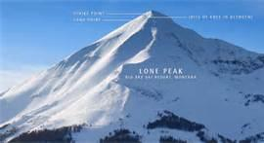
After a day of activity, we can enjoy the sauna and hot tub onsite at Summit Hotel at Big Sky. Concierge services are also available. Carabiner Lounge featuring Lone Peak fantastic mountain views offers year-round indoor and outdoor dining. The Peaks Restaurant offers us the convenience of fine dining while the Lone Peak Café lets us enjoy an al a carte dining experience when we are on the go!

S.E.E. Mates Member Price: $ 1,699 (per person, double occ.) and single supplement: $700. And there’s more! Save $75.00 when you deposit by April 15, 2021 on our Early Bird Special. Group Ski Pass is optional – an a great for non-IKON pass holders!

Trip Price Includes All of the Following:

- Roundtrip air from Boston-Logan to Bozeman, Montana
- Deluxe Motorcoach transfers from airport to/from the resort
- SEVEN nights in Summit Hotel at Big Sky (dbl occ) with full breakfast daily
- Welcome Party hosted by S.E.E. Mates Ski & Travel Club & Big Sky Resort
- Complimentary orientation session by Big Sky Staff
- One hosted Apres-ski gathering including appetizers
GROUP SKI PASS OPTIONS
5 of 6 day Ski Pass – add $550

with pay-as-you-go beverages
- One group dinner with pay-as-you-go adult beverages
- Baggage Tags and travel packets for all participants
- All resort & airline taxes, surcharges and fees (subject to change), driver. bell service gratuities

Not included: airline checked baggage fee; items of personal nature, and services not listed above.

To sign up or obtain additional info please contact: Kathy Ryan @ 978 270 9302 or email kathleen@myseemates.com
Initial deposit of $500 due ASAP to confirm your spot for this popular trip.
Please make checks payable to SEE Mates, LLC and mail to S.E.E. Mates, LLC P.O. Box 543, Newburyport, MA 01950

Enclosed is my (our) $500 per person deposit(s) for the Jan.8-15, 2022 BIG SKY Trip.

Name(s)_____________________________________ Rooming with:
(as appears on your Gov’t ID) Email :
Address___________________________________ Home Phone:
___________________________________ D.O.B. - required by TSA: Emergency contact:

Yes, I have read and understand the cancellation & refund policies on the reverse side.

Signature: _______________________________________ Date: __________________

RESPONSIBILITY CLAUSE

S.E.E. Mates, LLC and or its agents, act in the capacity of agent for the passengers in all matters pertaining to travel, whether by plane, rail, boat, steamer, or any other means of conveyance. They shall not be liable for any injury, damage, or loss occasioned by neglect or default of any company or person engaged in conveying the tour, or any hotel proprietor or car rental organization or other persons supplying services or materials in connection with the tour. Neither S.E.E. Mates, LLC (and or its agents) nor the airline concerned are to be held responsible for closure of access routes to or from resorts due to bad weather or road conditions, or for any other reasons beyond their control. In addition, they are not to be held liable for any additional payment or any refunds for unused hotel accommodations or meals occasioned by such late arrivals at hotels holding rooms as per confirmed itineraries or any other hotel. S.E.E. Mates, LLC and its agents act only as agents for reservations concerning hotels, transportation and sightseeing tours (if included) and do not guarantee the psychological satisfaction of the client for these reservations. Neither the club or agency nor its agents assume any responsibility or liability for schedule and time changes of airline, transfer companies and trains.

DEPOSIT / PAYMENT REQUIREMENTS
$500 deposit per person due ASAP to hold space (due by May 15, 2021)
Deposit by April 15, 2021 and receive $75.00 off your final payment
Second deposit of $500 per person due July 15, 2021

Final payment / the remainder of balance due by September 15, 2021

Sorry, credit cards will not be accepted for this trip, price reflects cash discount
Cancellation penalties will apply after May 15. *Attempts will be made to provide a suitable roommate,
but if one is not found, or if your cancellation leaves your roommate single, a supplement may be incurred.

CHANGE OF ITINERARY

Any changes in the itinerary will result in a $100 change fee, plus any additional charges as a result of the change--if the change is possible. There will be no refunds for any unused portions of the trip as the group rates are based on everyone following the same itinerary.

CANCELLATION & REFUND POLICY

Some restrictions and penalties apply to your vacation investment. If you cancel your reservations, YOUR RIGHT TO A REFUND IS LIMITED, as set forth in the following schedule. All cancellations must be discussed with the trip organizer and be in writing to S.E.E. Mates Ski & Travel Club, 106 Water Street, Newburyport, MA 01950. Date of postmark will determine applicable policy:

After June 1, 2021 and up to 120 days (Sept. 10, 2021) prior to departure cancellation policy is as follows:
A: Any and all cancellations are subject to a $95.00 per person contracted administration fee up until 120 days prior to departure.
B: Any and all cancellations received 119 to 91 days prior to departure - $ 395.00 per person contacted cancellation fee.
C: Any and all cancellations received 90 to 61 days prior to departure - $ 695.00 per person contacted cancellation fee.
D: Any and all cancellations received 60 days or less to departure – no refunds.

No refunds for early departure or late arrival. No shows, no refund. No partial refunds will be made on car rentals, airfare, or unused portions of this package.

Refunds will be made as soon as they are received from vendors (minimum eight (8) weeks).

TRIP INSURANCE
We strongly recommend the purchase of trip insurance covering, accident, sickness or death of a participant or covered family member that would result in cancellation either prior to or during the trip.

Trip participants can go to www.myseemates.com Big Sky event page and click on the Travel Insured link to sign up for trip insurance.

